TERRAFORM – TASK – 05
===========================================================================

- Title | - Terraform Remote Backend Setup, EC2 Web Server Deployment, Local File Creation, and Debug Logging
- Objective | - 1) Store Terraform state remotely in AWS S3 with locking using DynamoDB. 2) Create and manage an EC2 instance using Terraform. 3) Use local-exec provisioner to generate output files locally. 4) Create a local file resource using Terraform (local_file). 5) Enable Terraform debug logging (TRACE) and verify logs. 6) Deploy an EC2 Apache HTTP web server using user_data and verify output through Public IP in browser.
- Prerequisites | - 1) AWS account with required permissions (S3, DynamoDB, EC2). 2) Terraform installed on system. 3) AWS CLI configured OR AWS credentials available in system. 4) VS Code installed (for editing Terraform files). 5) Internet access for downloading Terraform providers. 6) Existing S3 bucket created for storing Terraform state. 7) Existing DynamoDB table created for Terraform state locking. 8) EC2 key pair available (if SSH access required).
- Errors and How I Fixed Them | - Error/Warning 1: Terraform backend migration prompt displayed during terraform init when backend changed to S3. ✅ Fix: Entered yes to copy existing state to the new S3 backend successfully. Error/Warning 2: acl is deprecated warning for S3 bucket ACL argument. ✅ Fix: Replaced old ACL argument with the updated Terraform resource aws_s3_bucket_acl instead of using acl inside aws_s3_bucket. Error/Issue 3: Needed proof that Terraform executed commands (debugging requirement). ✅ Fix: Enabled Terraform logs using PowerShell environment variables: TF_LOG=TRACE and TF_LOG_PATH=terraform.log and verified log file creation. Error/Issue 4: Web page not accessible initially without HTTP service setup. ✅ Fix: Added user_data script to install and start httpd, enable service, and create /var/www/html/index.html automatically.
- Conclusion | - Successfully configured Terraform with remote backend (S3) and state locking (DynamoDB). Created and managed AWS resources like EC2 instances, verified deployments using AWS Console, and accessed the hosted Apache web server using the instance Public IP. Also created local resources (pets.txt) using Terraform, generated output file using local-exec provisioner, and captured detailed execution logs using Terraform TRACE logging for troubleshooting and verification.

2. Execute the script shown in the video.
- Open VS Code → open your Terraform folder.
- Create/Open main.tf.
- Add S3 bucket resource code:
- resource "aws_s3_bucket" "s3_bucket" {
- bucket = "ironman3000"
- acl = "private"
- }
- Open Terminal in VS Code.
- Run:
- terraform init
- Confirm message: Terraform has been successfully initialized!

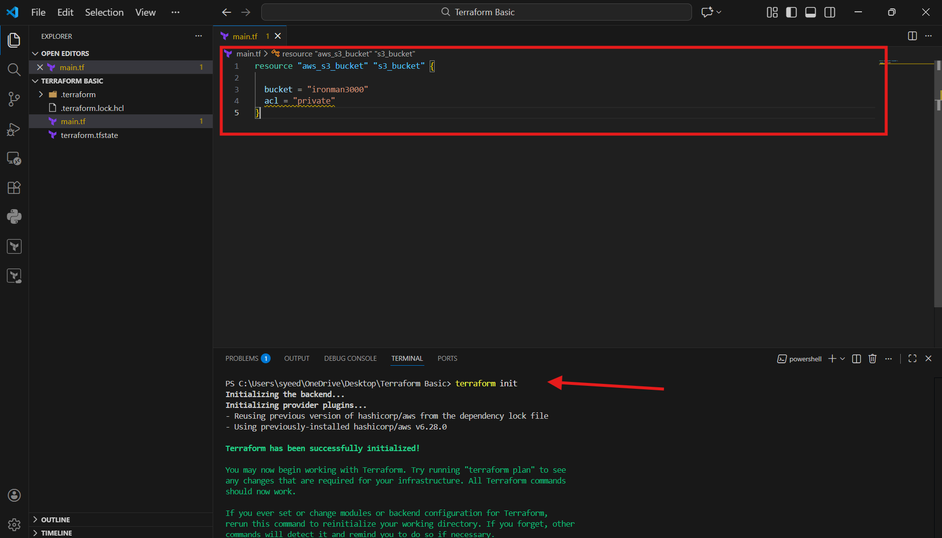
- In VS Code terminal, run:
- terraform apply
- Terraform shows execution plan (what will be created).
- Check that it shows:
aws_s3_bucket.s3_bucket will be created
- Continue to approval step.

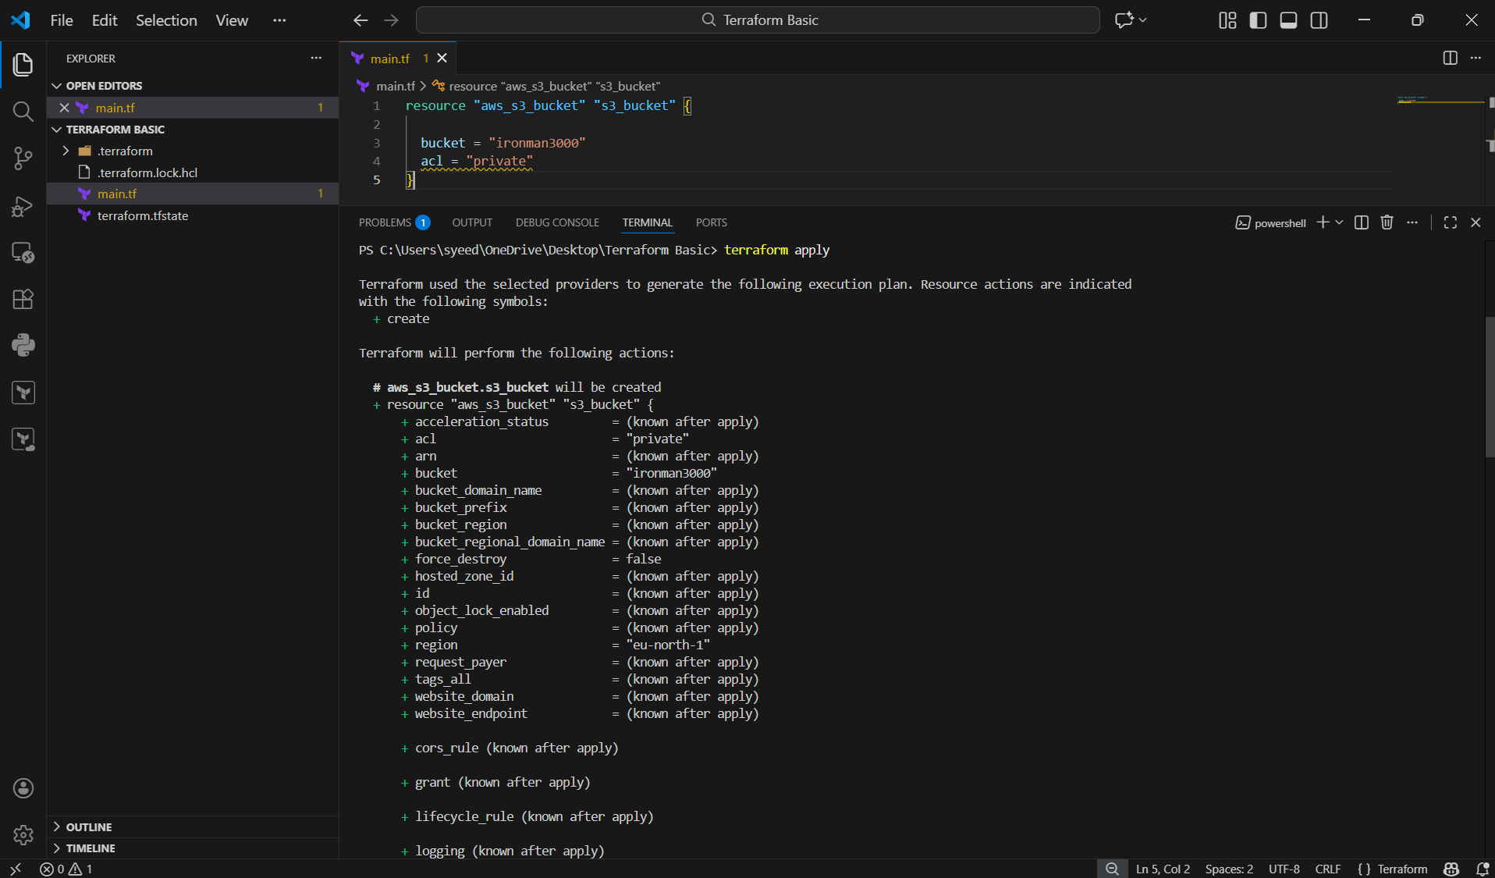
- When Terraform asks:
- Do you want to perform these actions?
- Type:
- yes
- Terraform creates S3 bucket successfully.
- You may see warning:
acl is deprecated
- Confirm success line:
Apply complete! Resources: 1 added

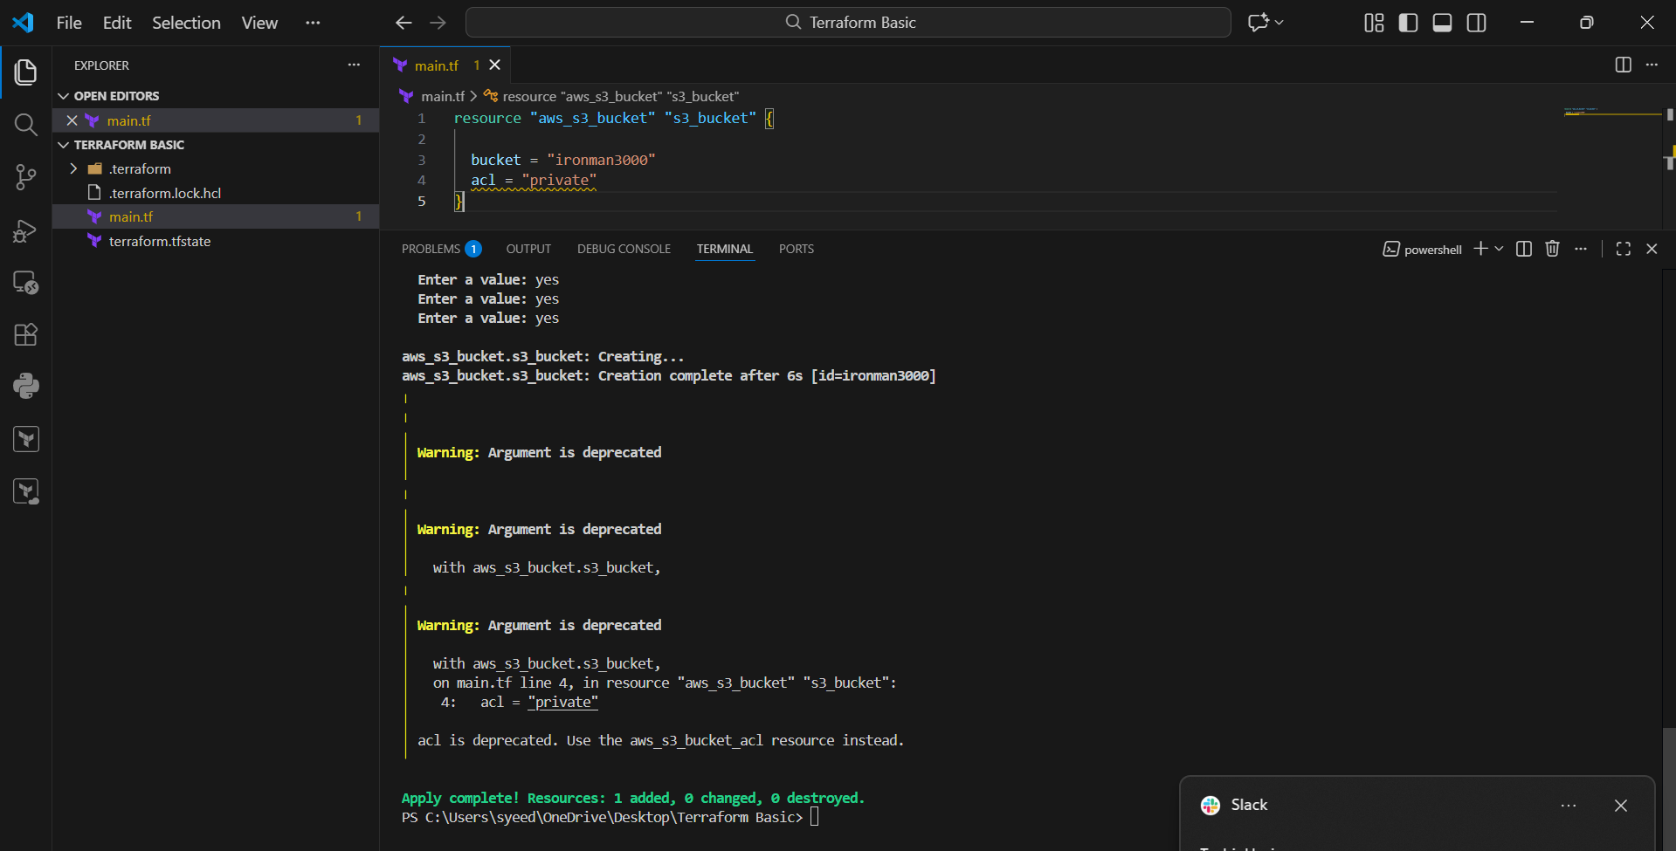
- Login to AWS Console.
- Go to:
S3 → Buckets
- Search bucket name: ironman3000
- Confirm bucket exists in the bucket list

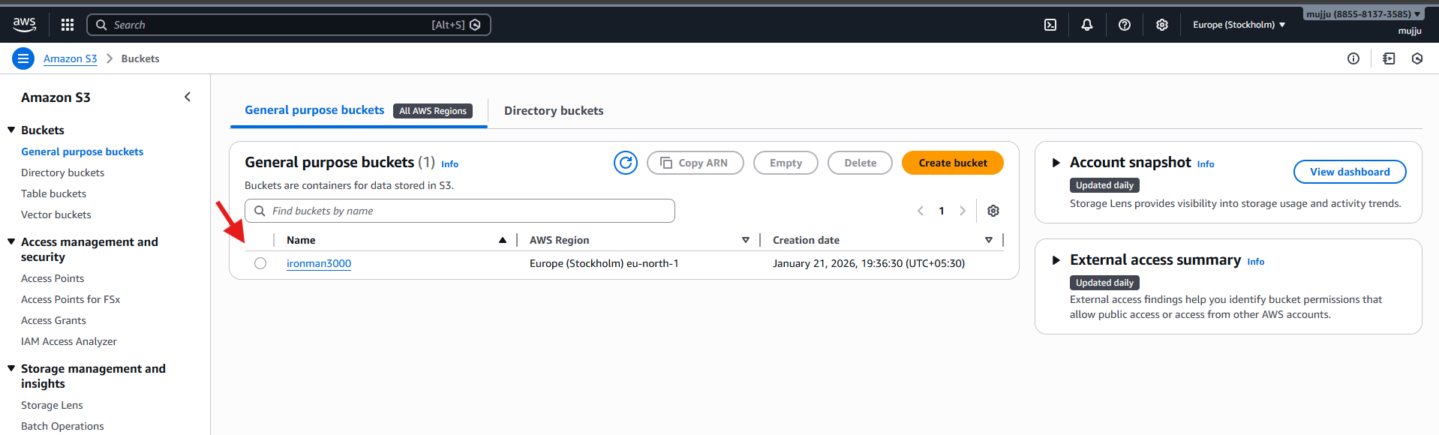
- Open main.tf in VS Code.
- Keep existing S3 bucket code.
- Add DynamoDB table resource below it:
- resource "aws_dynamodb_table" "dynamodb-terraform-state-lock" {
- name = "terraform-state-lock-dynamo"
- hash_key = "LockID"
- read_capacity = 20
- write_capacity = 20

- attribute {
- name = "LockID"
- type = "S"
- }
- }
- Save the file.

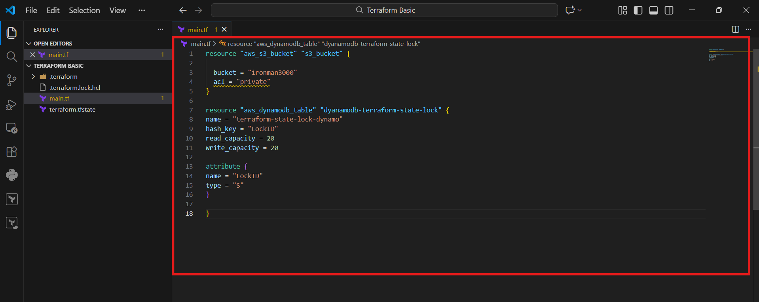
- Open terminal in VS Code.
- Run again:
- terraform init
- Confirm initialization is completed successfully.

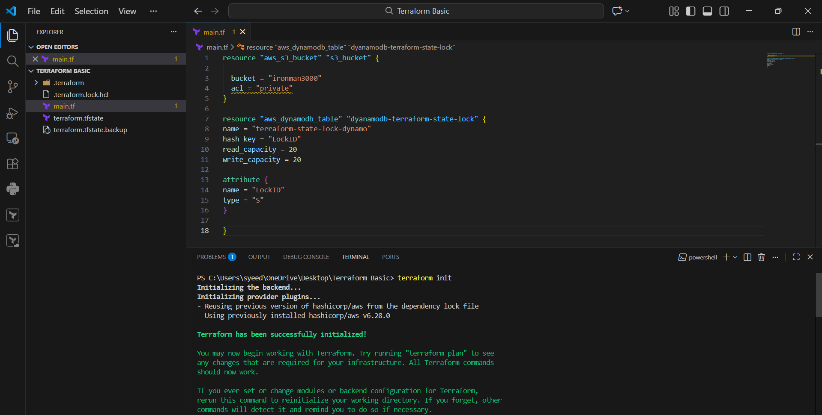
- Run:
- terraform apply
- Terraform shows plan and indicates:
- aws_dynamodb_table.dynamodb-terraform-state-lock will be created
- Proceed to approval step

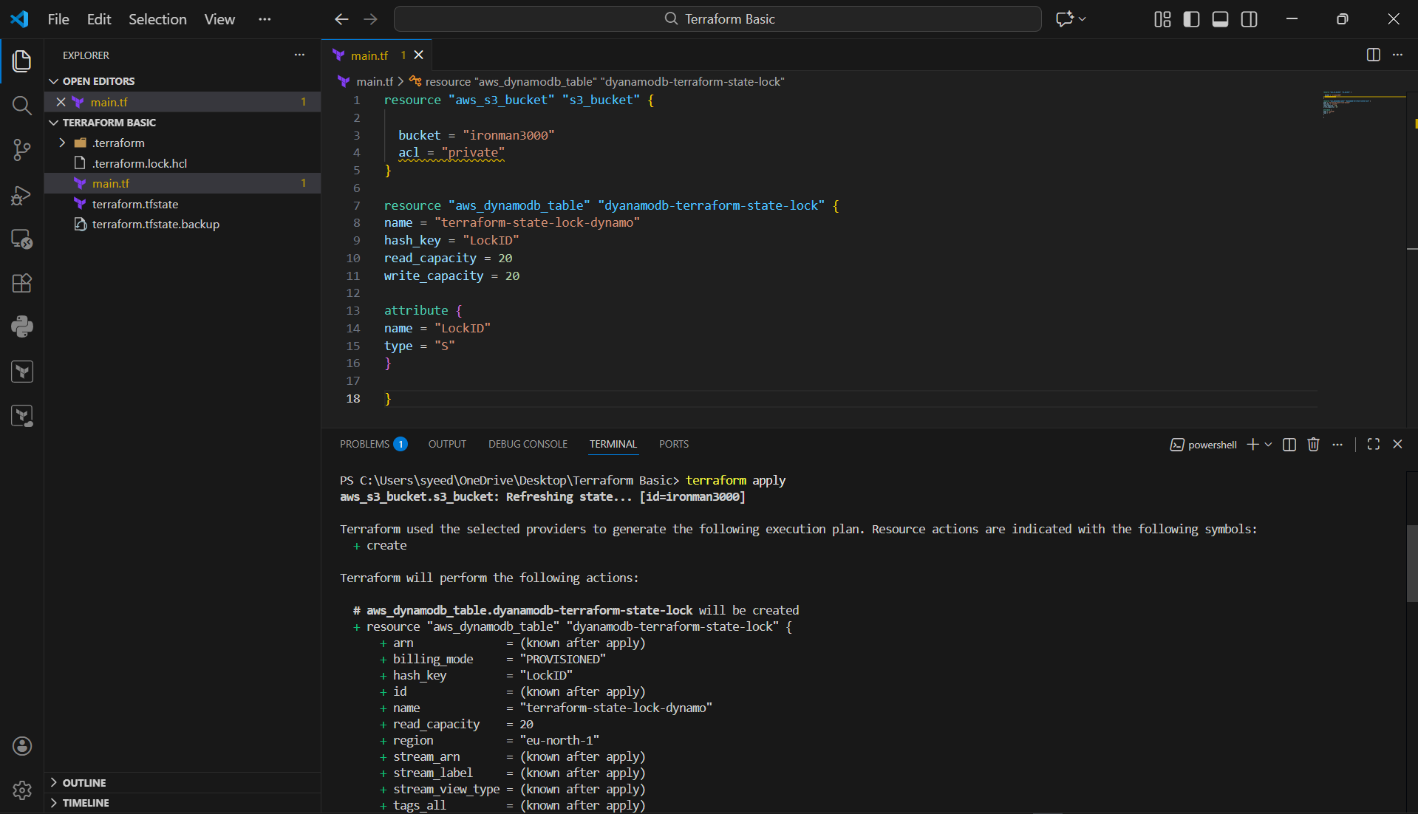

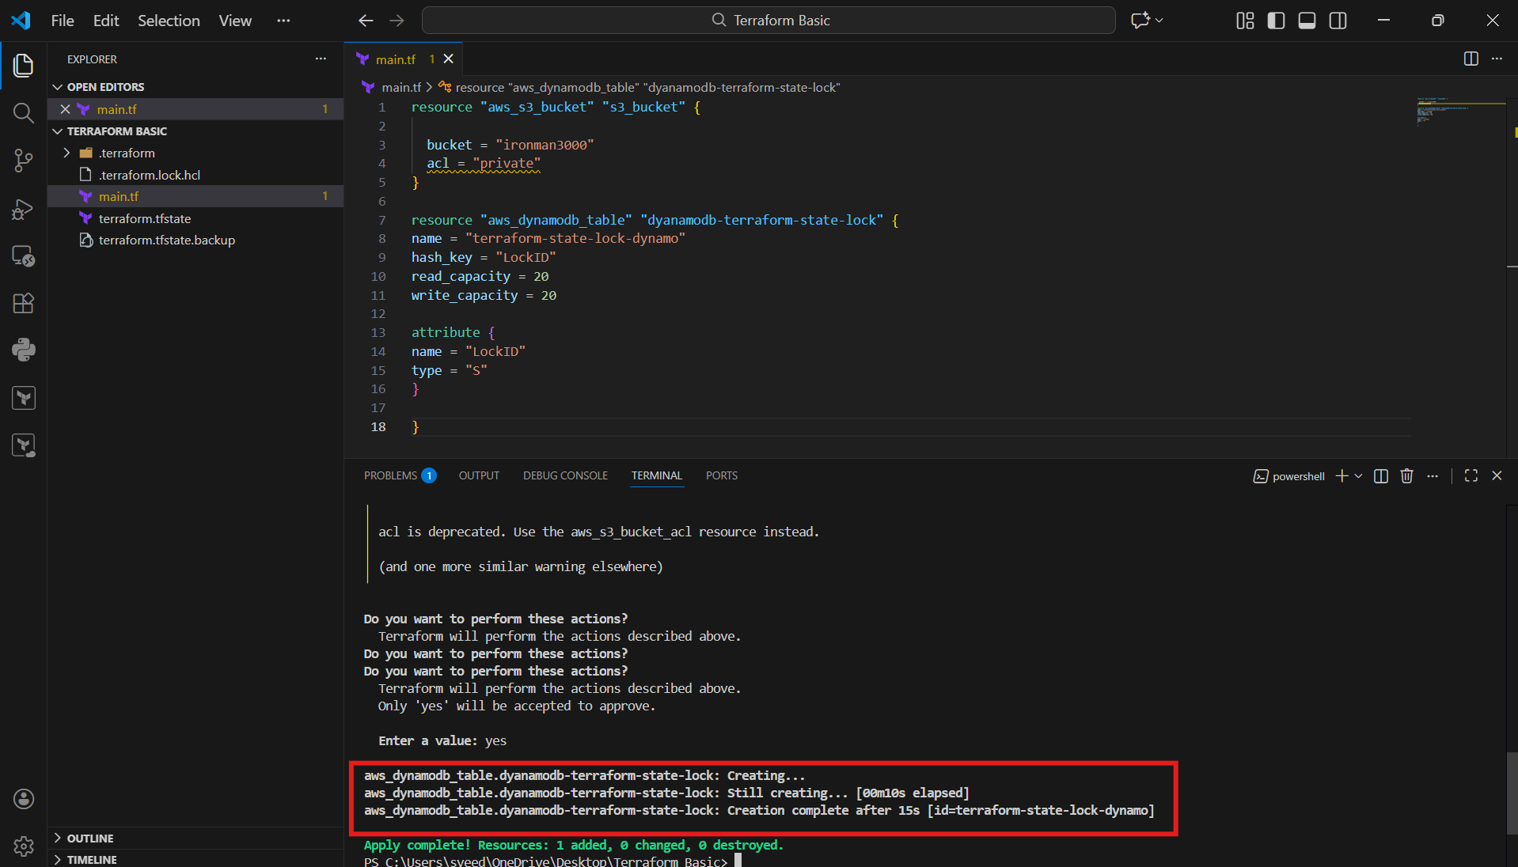
- Login to AWS Console.
- Go to:
DynamoDB → Tables
- Confirm table exists:
- terraform-state-lock-dynamo
- Status should show Active

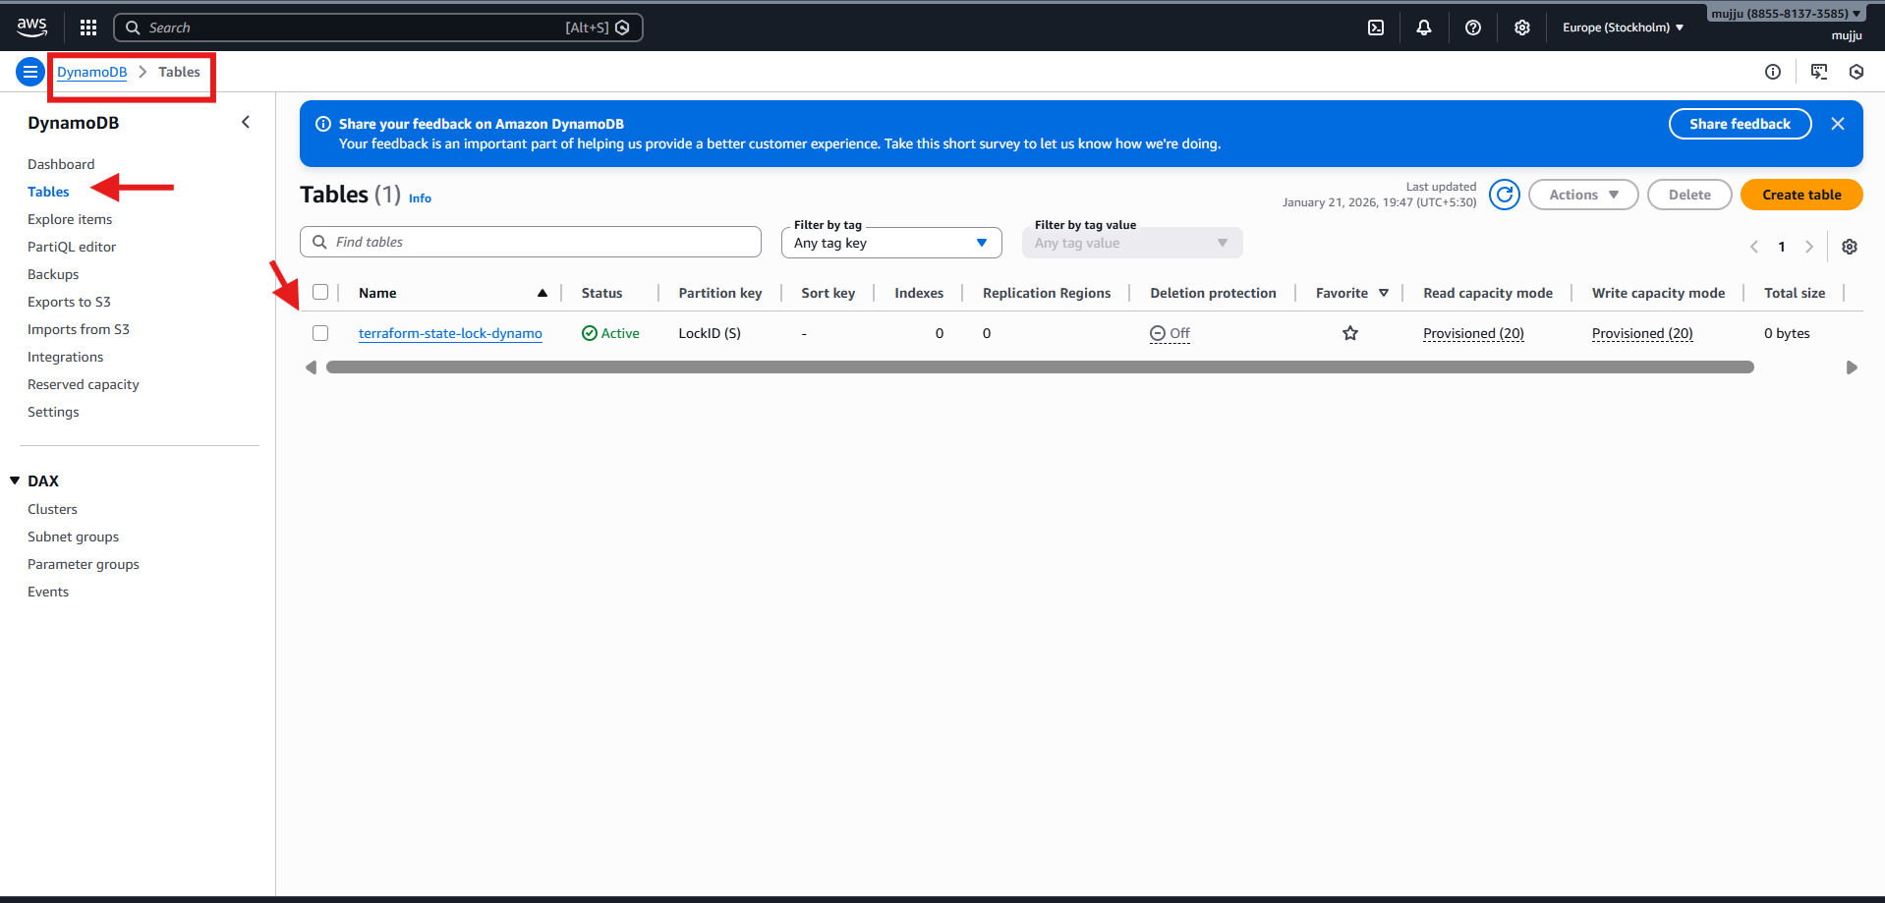
- Open main.tf.
- Replace deprecated S3 ACL line with proper ACL resource:
- resource "aws_s3_bucket" "s3_bucket" {
- bucket = "ironman3000"
- }

- resource "aws_s3_bucket_acl" "bucket_acl" {
- bucket = aws_s3_bucket.s3_bucket.id
- acl = "private"
- }
- Keep DynamoDB resource for state locking.
- Add backend block for storing Terraform state in S3:
- terraform {
- backend "s3" {
- bucket = "ironman3000"
- key = "terraform.tfstate"
- region = "eu-north-1"
- dynamodb_table = "terraform-state-lock-dynamo"
- }
- }
- Save file.
- Run:
- terraform init
- Terraform migrates state to S3 and enables locking using DynamoDB.

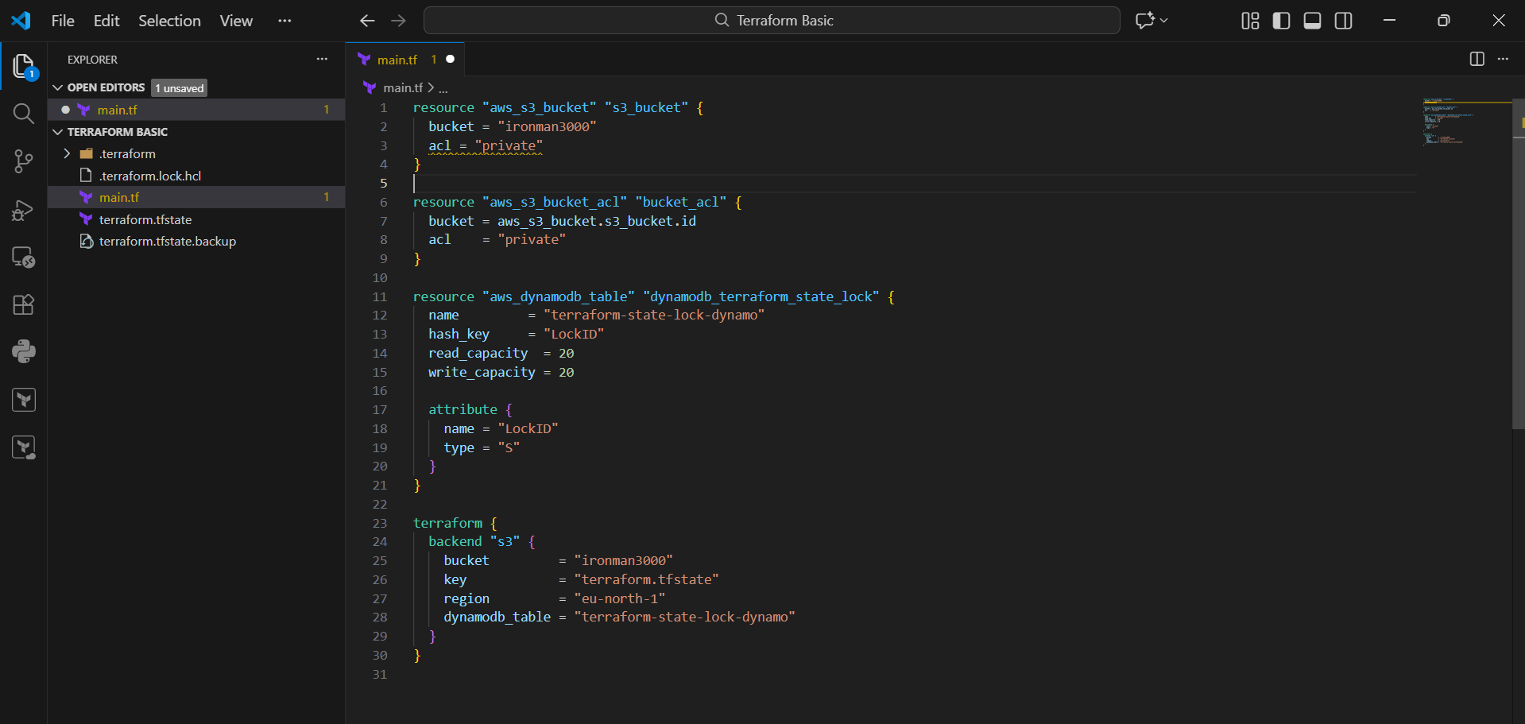
- Open VS Code → Terminal inside your Terraform project.
- Run:
- terraform init
- Terraform detects backend change and asks:
“Do you want to copy existing state to the new backend?”
- Type:
- yes
- Terraform completes backend setup and shows:
- Successfully configured the backend "s3"
- Terraform has been successfully initialized

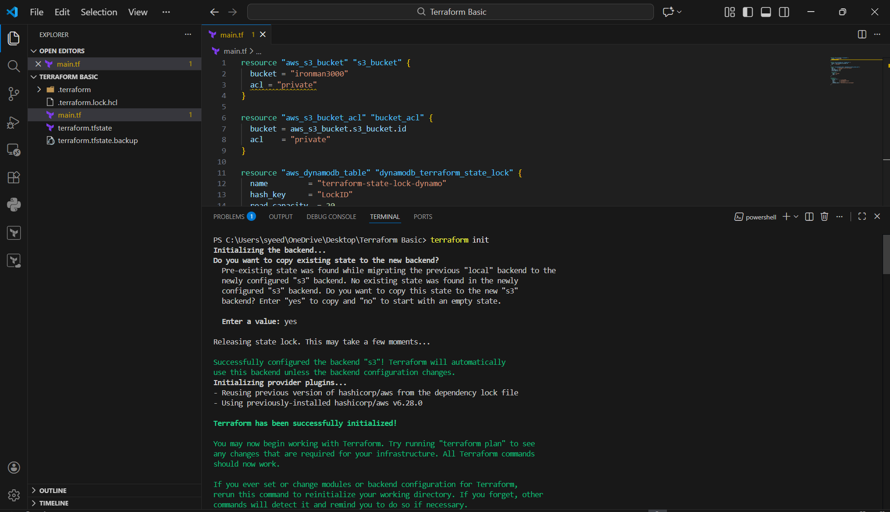
- Go to AWS Console
- Open:
S3 → Buckets → ironman3000
- Click Objects
- Confirm the state file exists:
terraform.tfstate
- This means Terraform state is now stored remotely in S3.

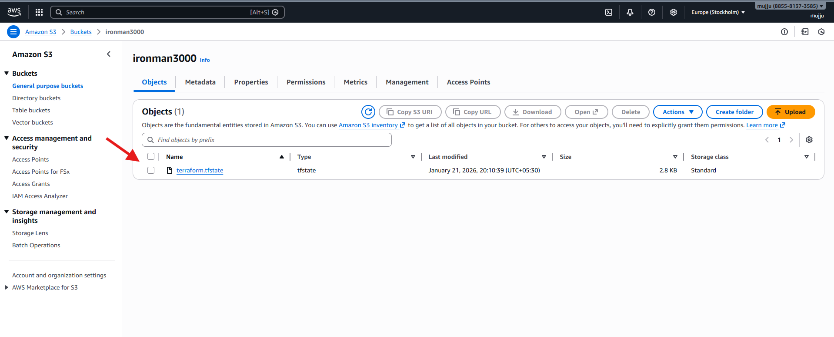
- Open main.tf in VS Code.
- Add EC2 resource code:
- resource "aws_instance" "webserver" {
- ami = "ami-0683e28a6f610487"
- instance_type = "t3.micro"
- key_name = "linux"
- }
- Save the file.
- Run:
- terraform apply
- Terraform shows the plan output for EC2 creation.

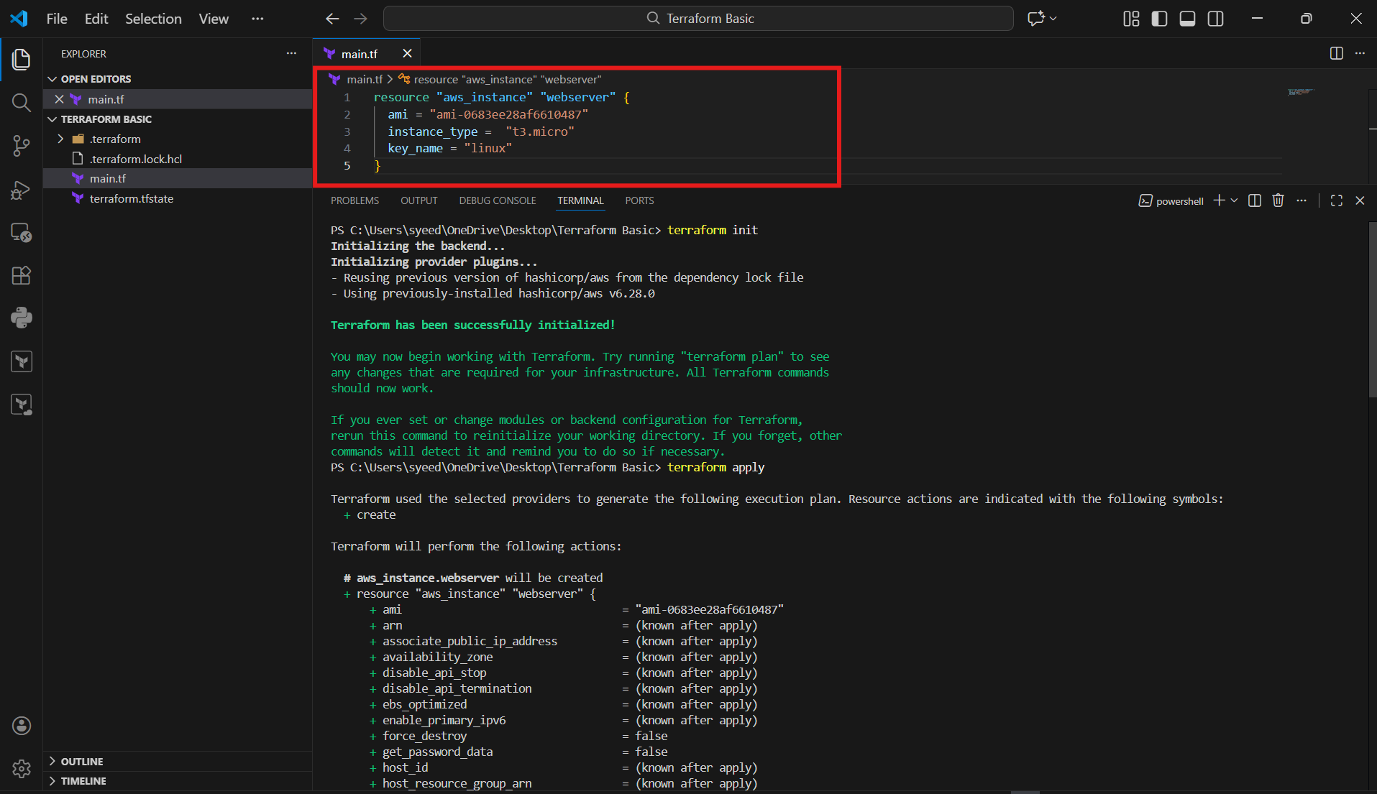
- When asked:
- Do you want to perform these actions?
- Type:
- yes
- Wait for creation to finish.
- Confirm output:
- Creation complete
- Apply complete! Resources: 1 added

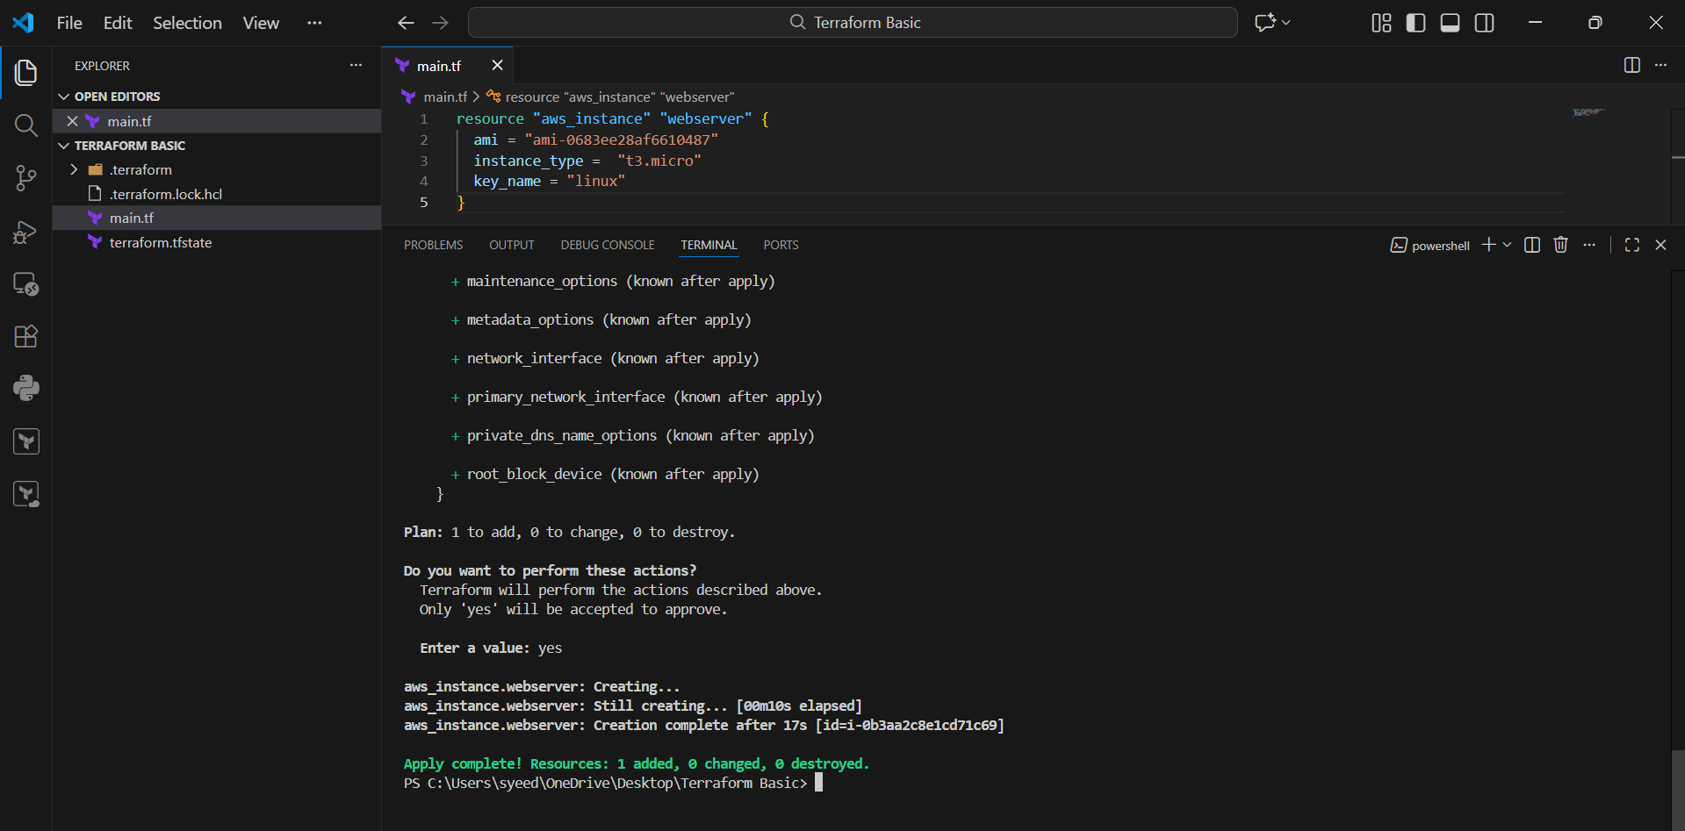
- Go to AWS Console
- Open:
EC2 → Instances
- Confirm the instance is visible and status is:
- Running
- You can verify details like:
- AMI ID
- Instance Type: t3.micro
- Public IP / DNS

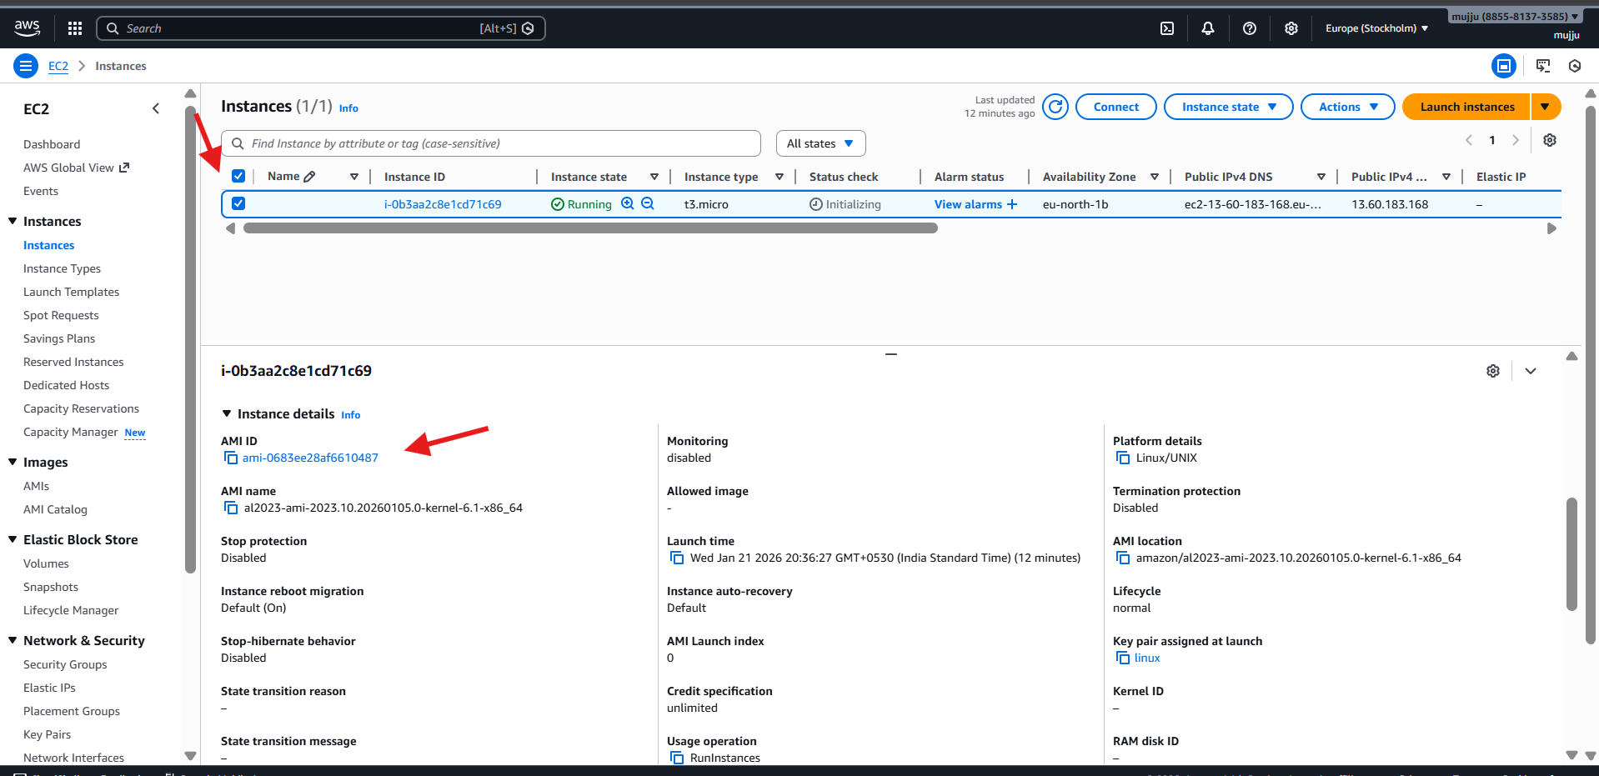
- In VS Code terminal, run:
- terraform destroy
- Terraform shows destroy plan:
aws_instance.webserver will be destroyed
- Continue to approval step.

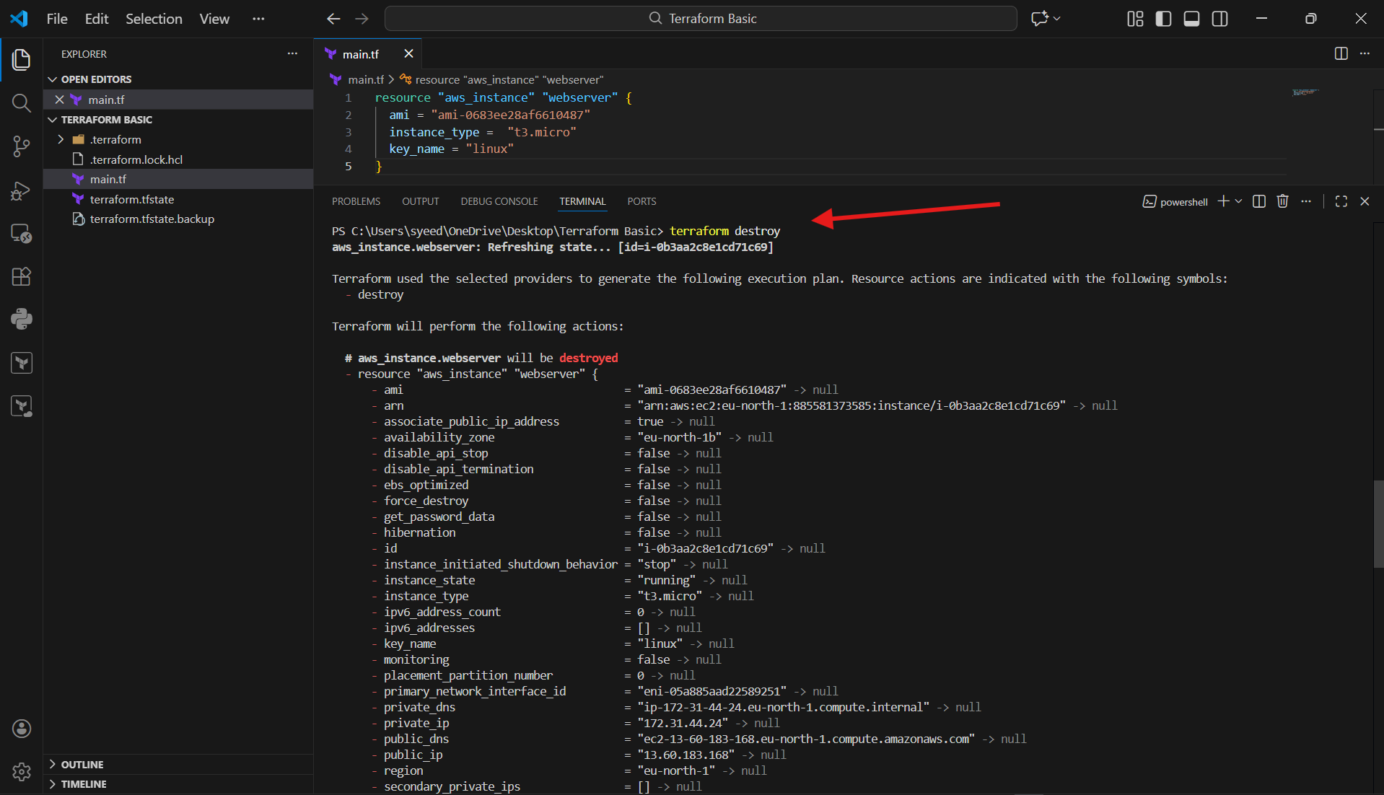
- Open AWS EC2 → Instances
- Refresh the page.
- Confirm the instance state changes to:
Shutting-down
then Terminated
- This confirms Terraform destroy removed the EC2 resource.

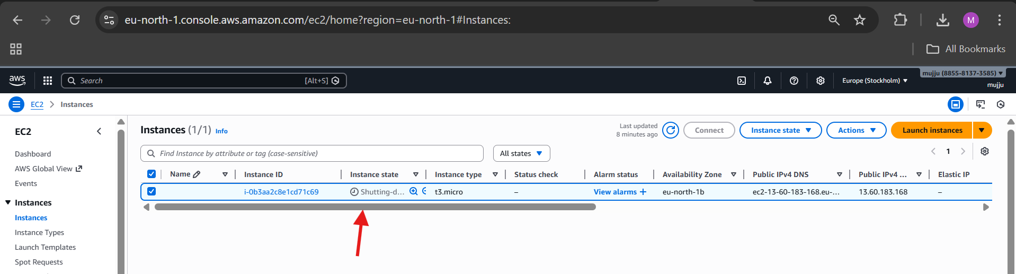
- Open main.tf
- Update EC2 resource to include provisioner:
- resource "aws_instance" "webserver" {
- ami = "ami-0683e28a6f610487"
- instance_type = "t3.micro"
- key_name = "linux"

- provisioner "local-exec" {
- command = "echo Instance ${aws_instance.webserver.public_ip} created! > instance-state"
- }
- }
- Save the file.
- This will create a local file named instance-state after instance creation.

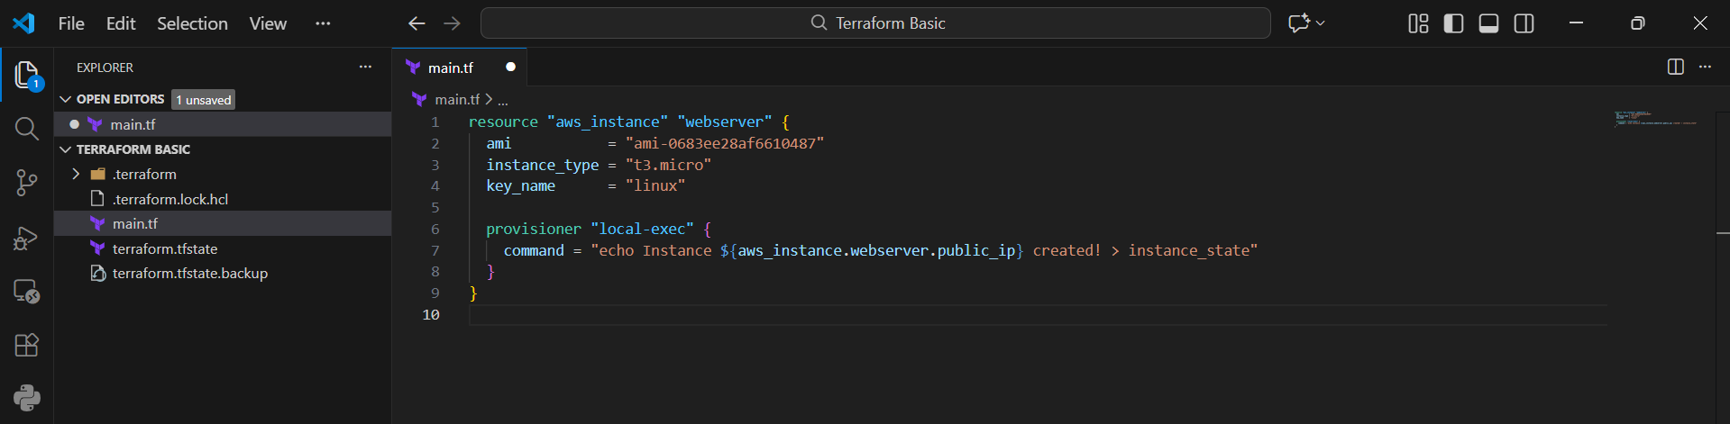
- Run Terraform init (safe even if already initialized):
- terraform init
- Run:
- terraform apply
- Terraform displays plan to create EC2 again.
- Approve when asked by typing:
- yes

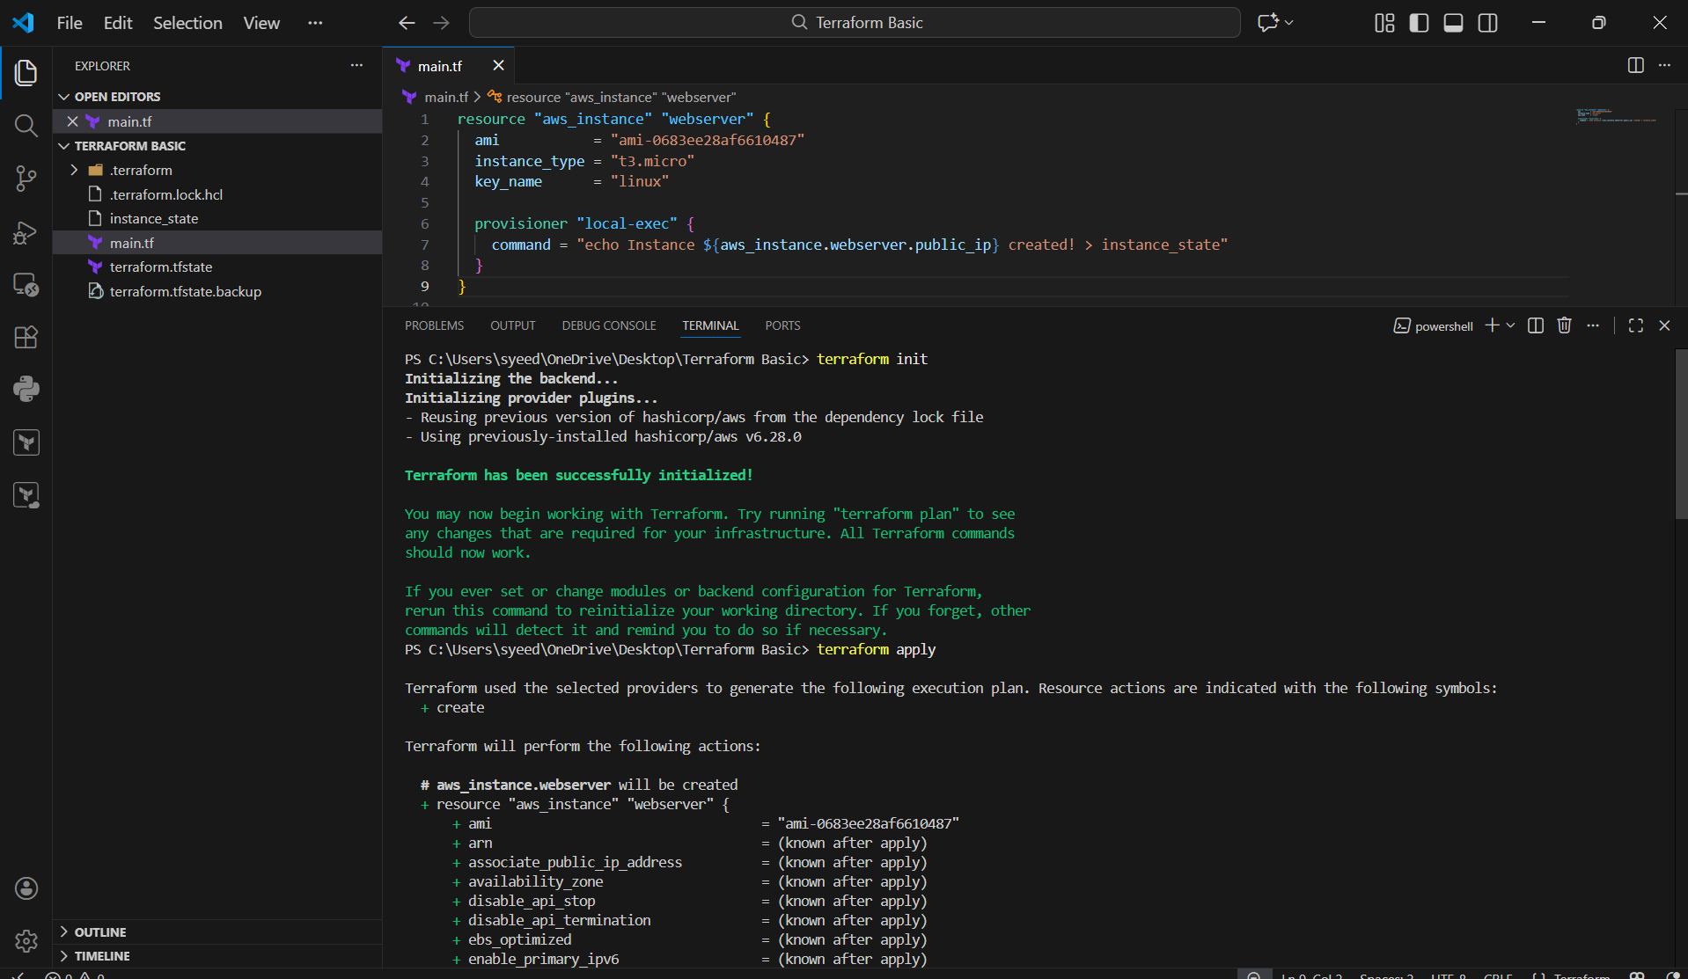
- After apply completes, check the Explorer panel in VS Code
- You will see a new file created:
- instance-state
- Open it to confirm content is written like:
- Instance <public-ip> created!
- This confirms local-exec provisioner worked successfully

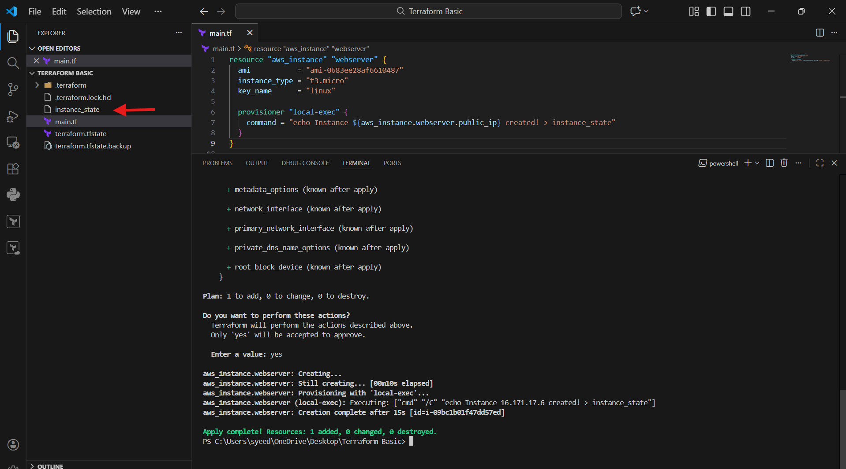
- In VS Code Explorer, click the file:
instance_state
- Open the file and verify the output message is written inside it.
- Example shown in image:
- Instance 16.171.17.6 created!
- This confirms local-exec provisioner successfully created and updated the file.

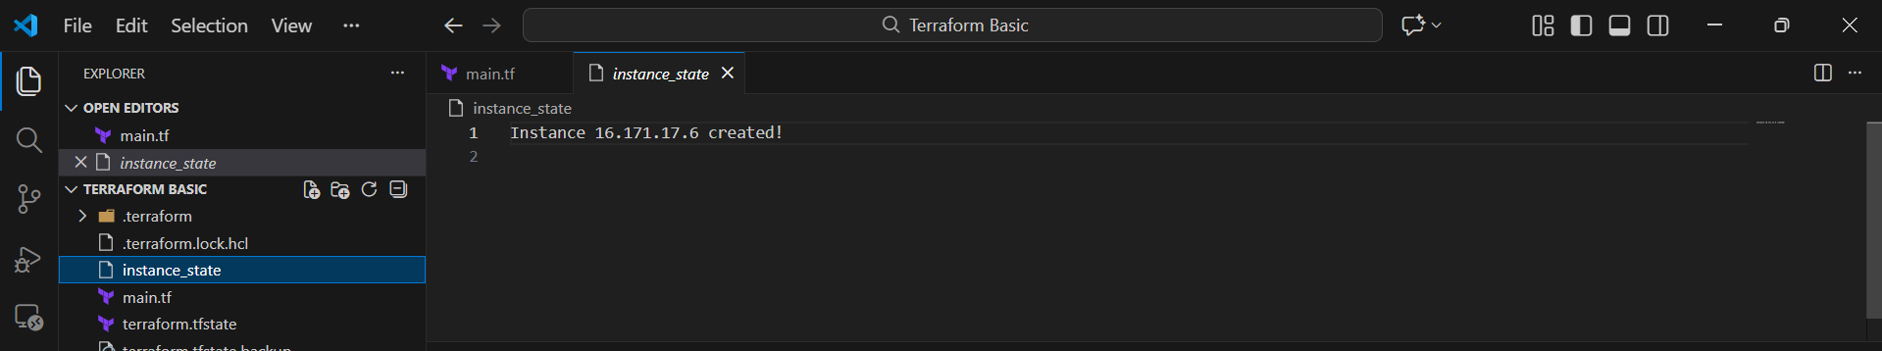
- Open main.tf
- Add Local file resource code:
- resource "local_file" "test" {
- filename = "pets.txt"
- content = "I love cats!"
- }

- provisioner "local-exec" {
- when = destroy
- command = "echo Deleted the file pets.txt > file.txt"
- }
- Save the file.
- Open terminal and run:
- terraform init
- Then run:
- terraform apply
- Terraform shows plan that local_file.test will be created.

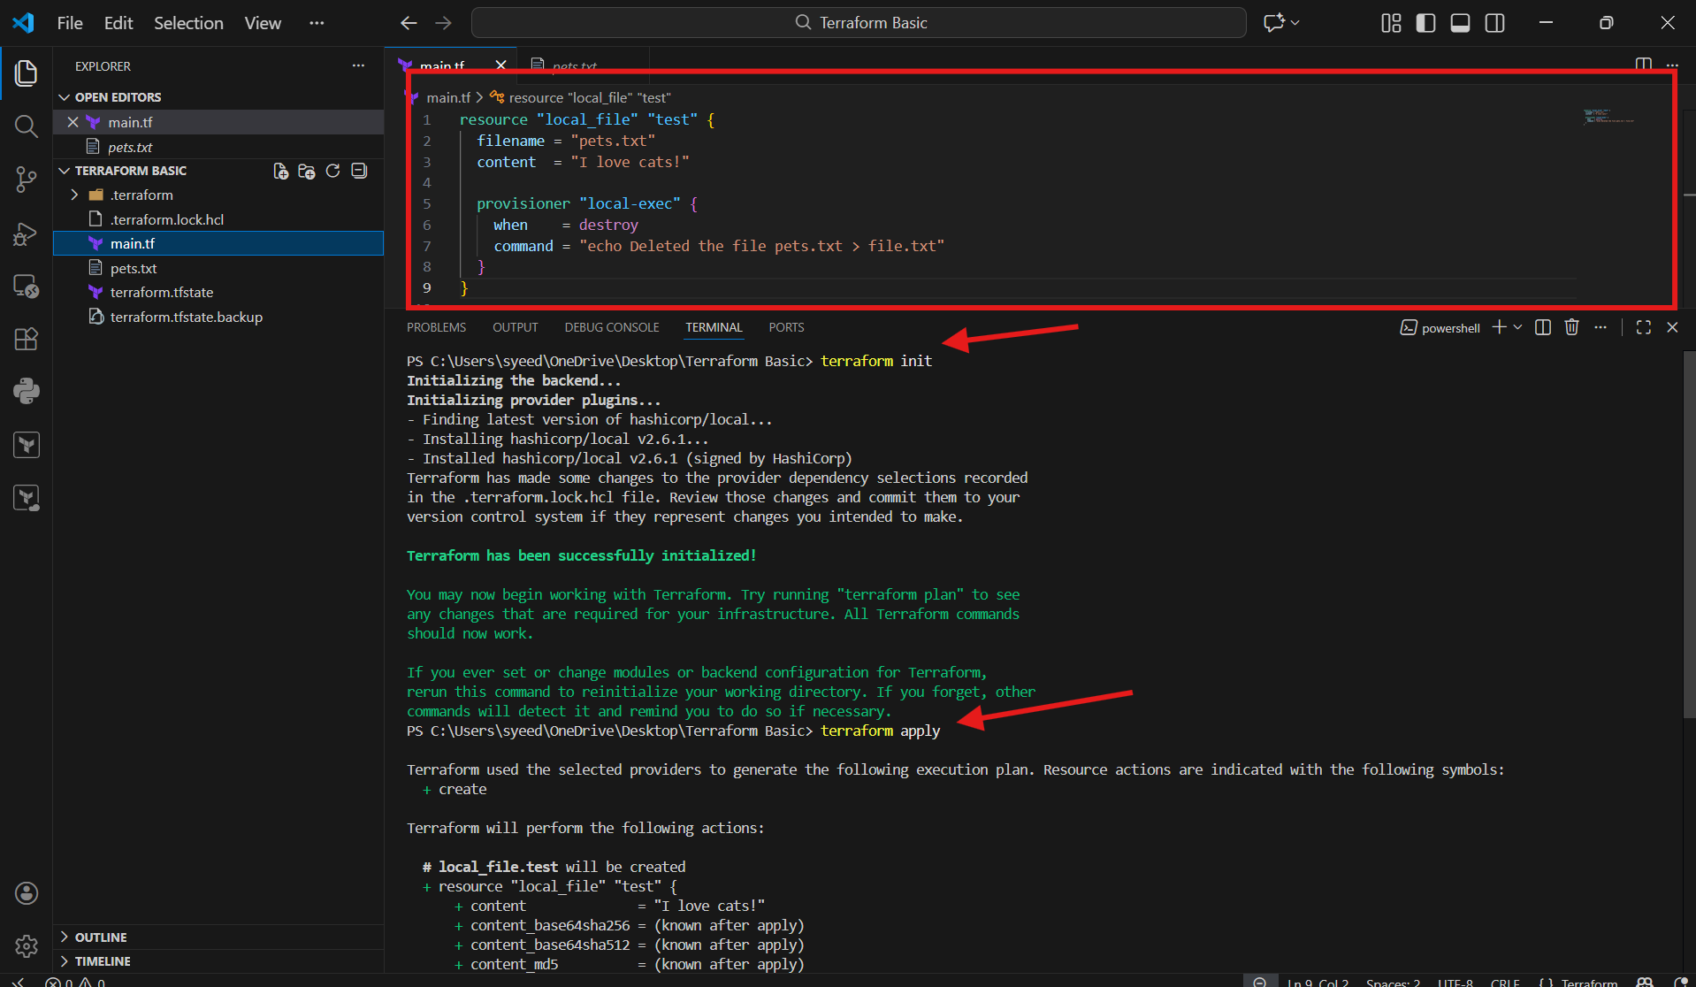
- In PowerShell terminal set Terraform log file path:
- Set-Item -Path env:TF_LOG_PATH -Value "terraform.log"
- Set log level:
- Set-Item -Path env:TF_LOG -Value "TRACE"
- Run apply again:
- terraform apply
- Terraform runs with detailed logs enabled.
- A new file appears:
terraform.log

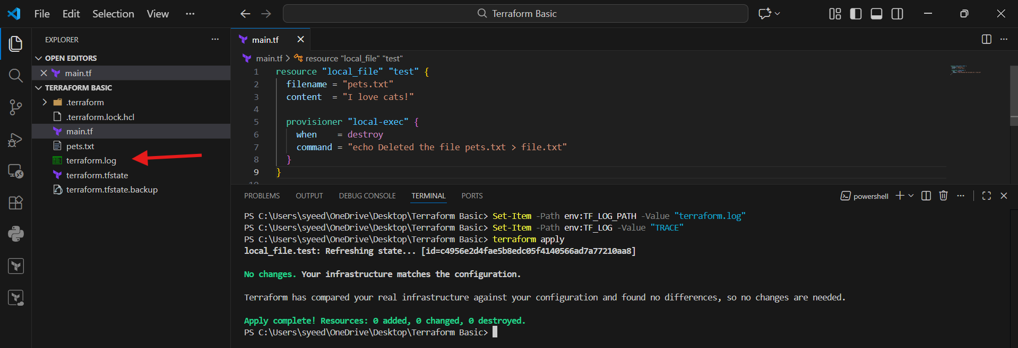
- In VS Code Explorer, click:
terraform.log
- Open the log file.
- Confirm it contains Terraform debugging information like:
Initialization logs
Provider logs
Backend logs
Apply execution logs
- This confirms TRACE logging is working properly.

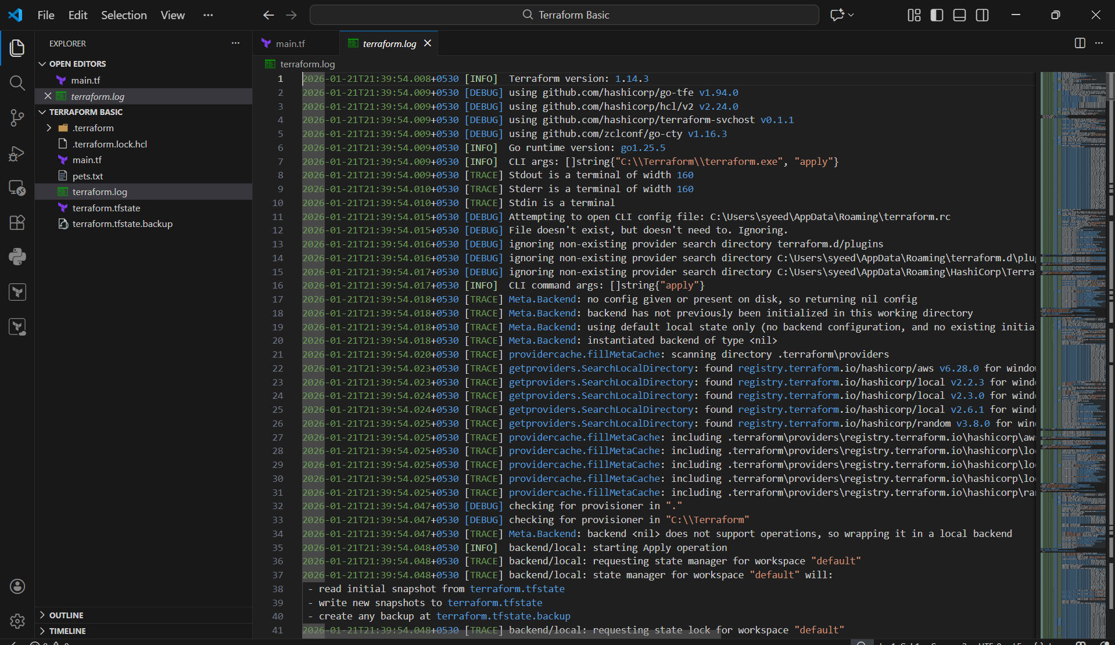

3. Create one EC2 instance with httpd installed using a Terraform script.
- Open main.tf
- Add/update EC2 instance code with user data script:
- resource "aws_instance" "webserver" {
- ami = "ami-0683e28a6f610487"
- instance_type = "t3.micro"

- user_data = <<-EOF
- #!/bin/bash
- yum update -y
- yum install -y httpd
- systemctl start httpd
- systemctl enable httpd
- echo "<h1>Terraform EC2 Web Server</h1>" > /var/www/html/index.html
- EOF

- tags = {
- Name = "Terraform-HTTPD-Server"
- }
- }
- Save the file.

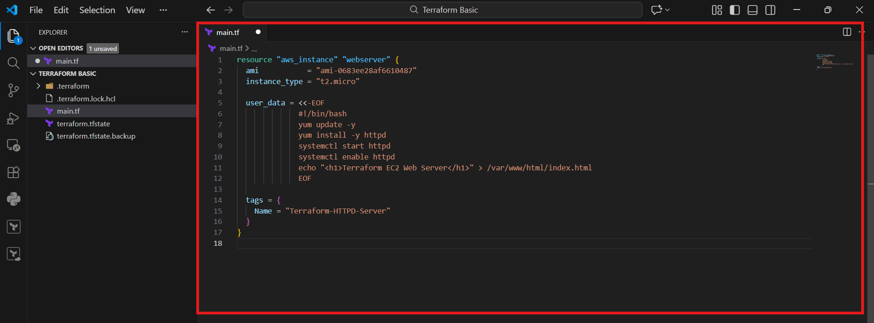
- Open terminal in VS Code.
- Run:
- terraform apply
- Terraform shows it will create:
- aws_instance.webserver
- Continue to approval step

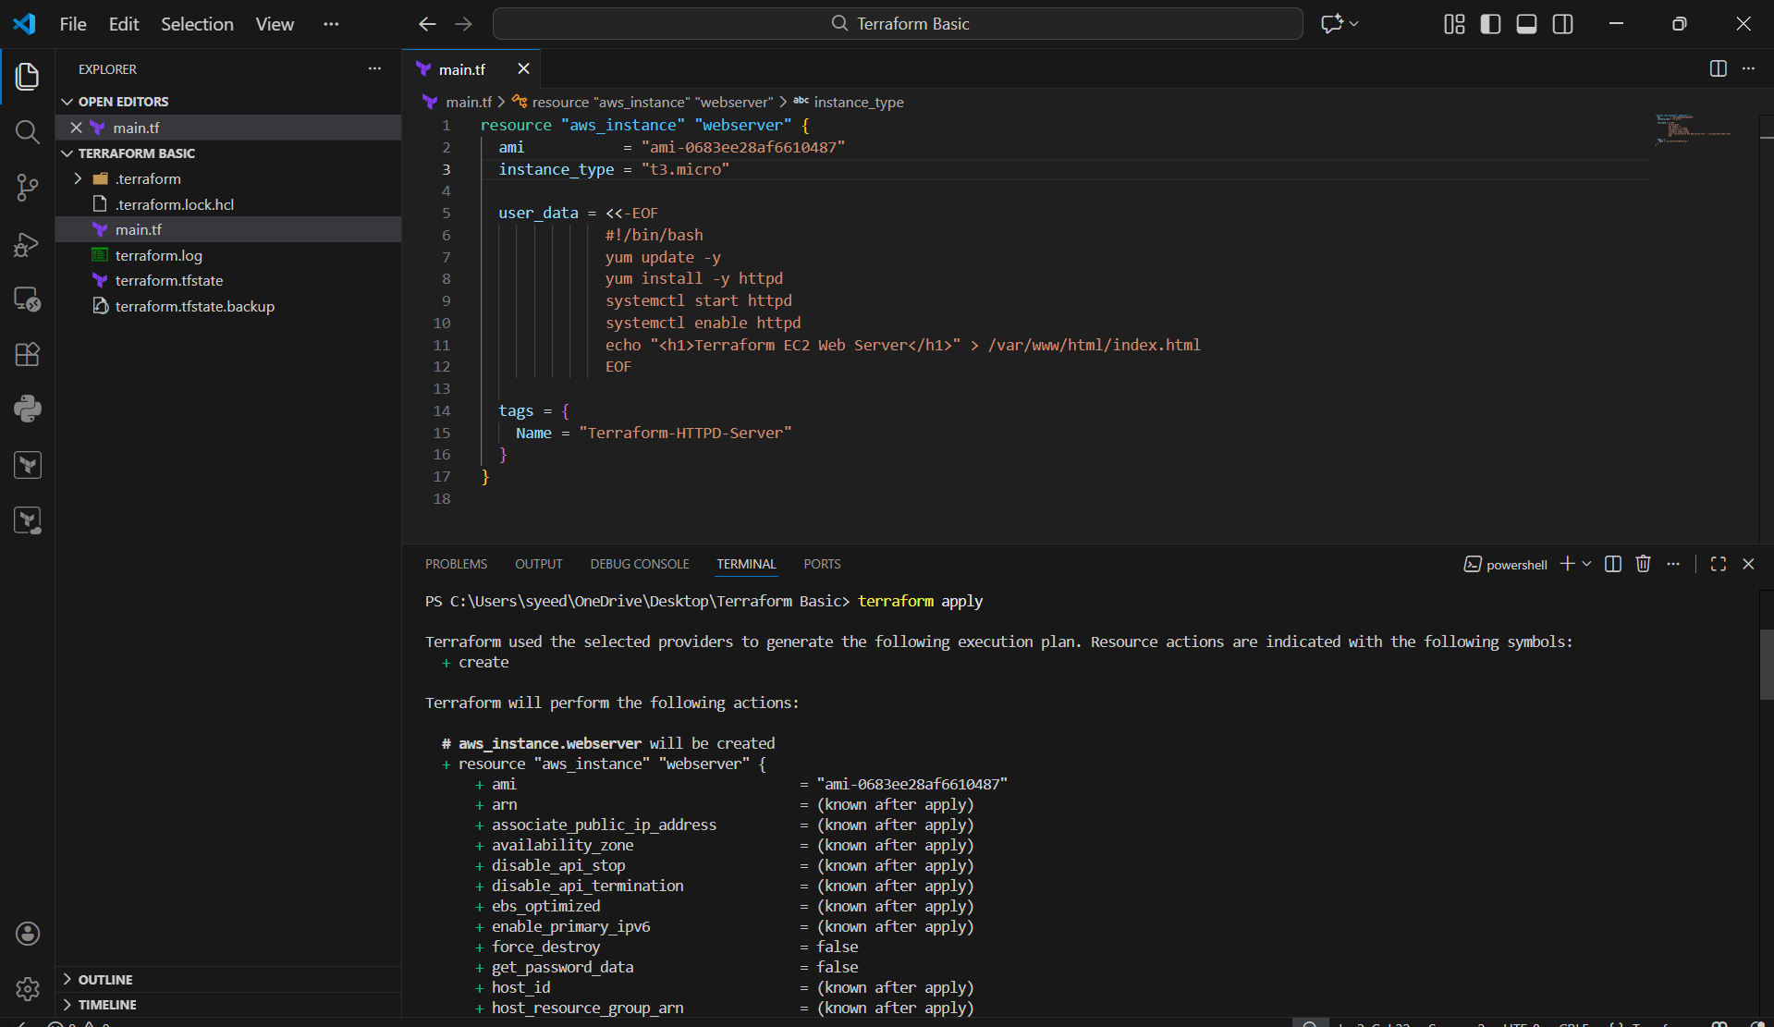
- Terraform asks:
- Do you want to perform these actions?
- Type:
- yes
- Wait until Terraform finishes creating the instance.
- Confirm success message:
- Apply complete! Resources: 1 added

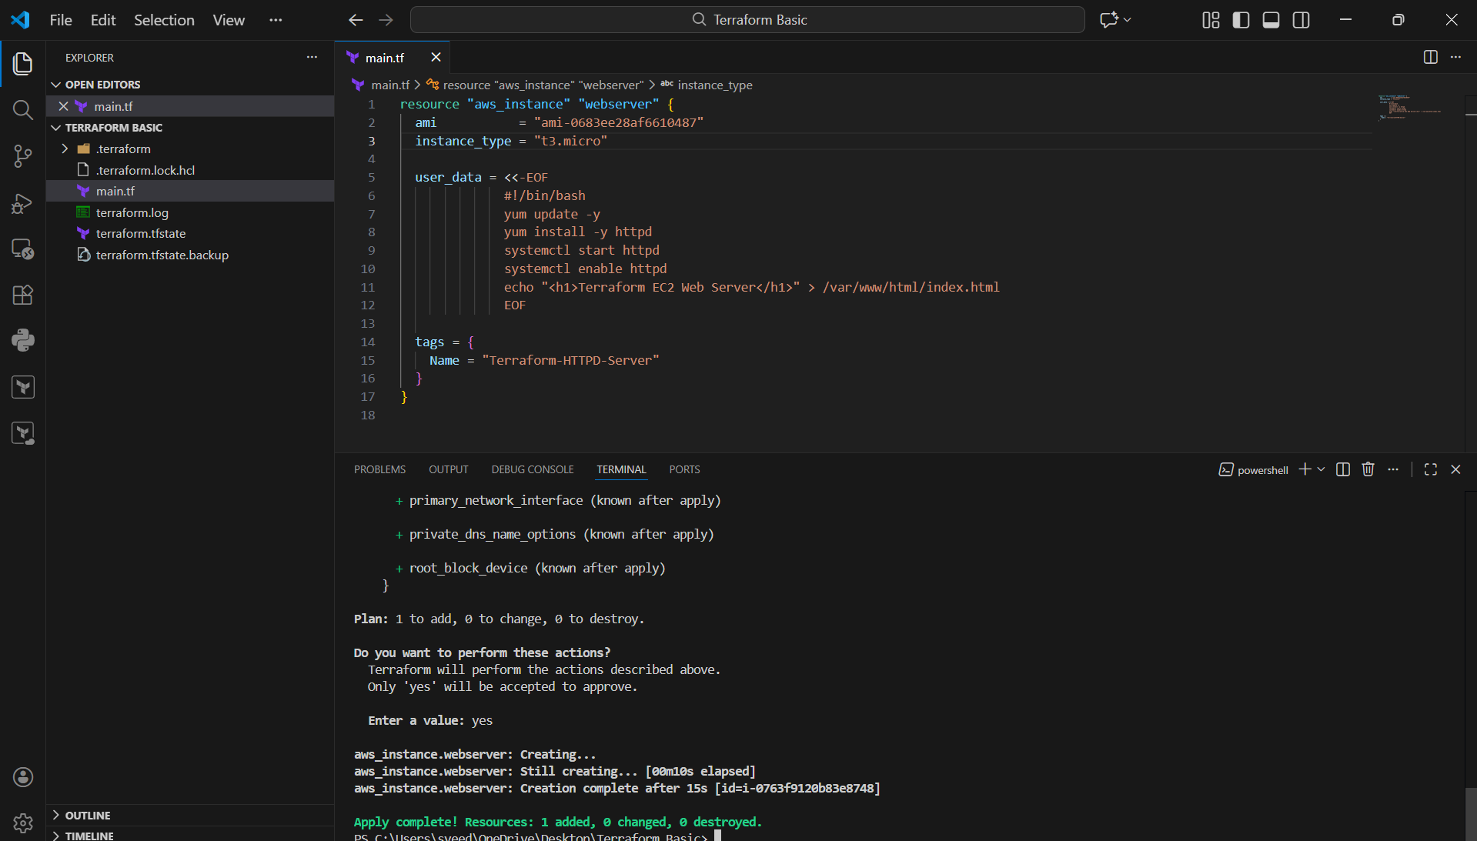
- Open AWS Console
- Go to:
EC2 → Instances
- Confirm the new instance is running:
- Name: Terraform-HTTPD-Server
- Status: Running
- Check the instance Public IPv4 address (shown in the table).

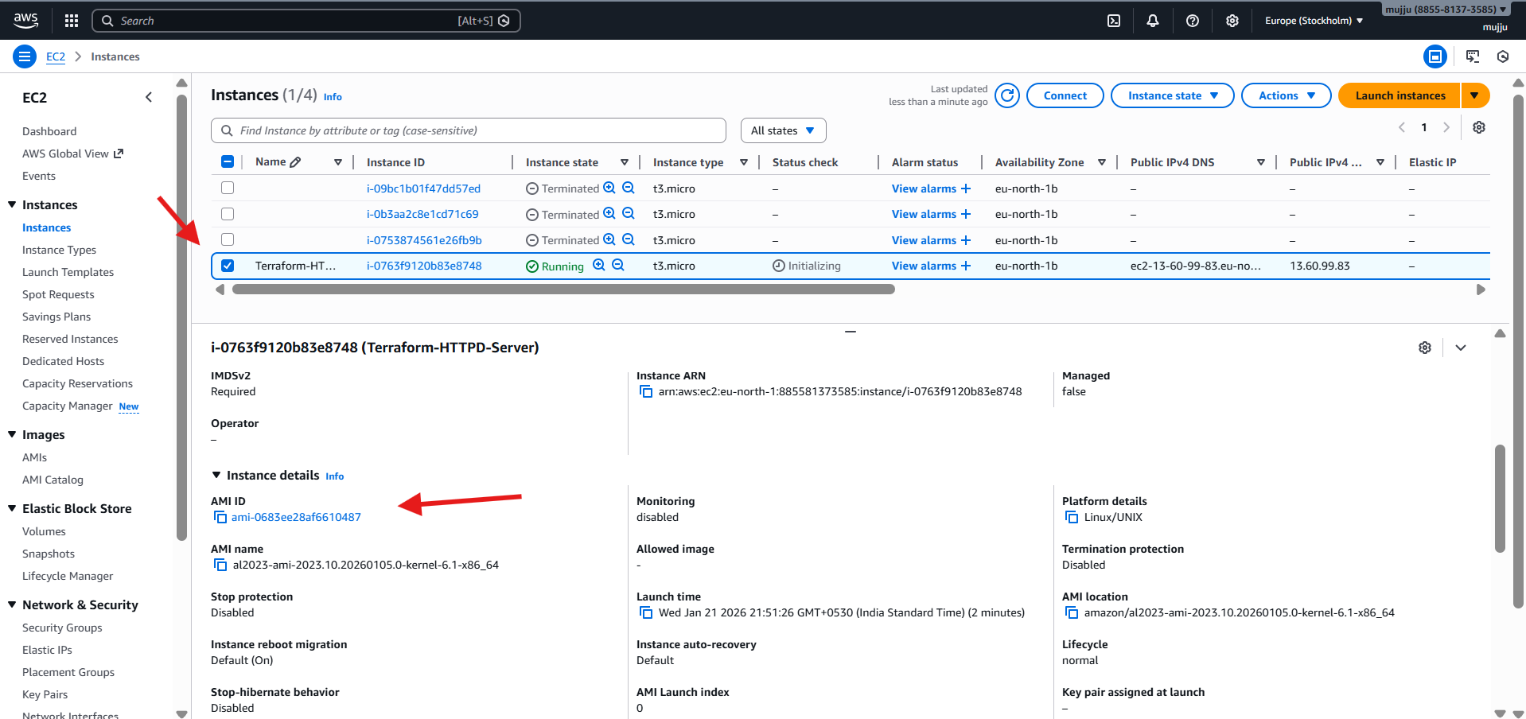
- Copy the EC2 Public IPv4 address
- Paste it in browser:
- http://<PUBLIC-IP>
- Page should load and display:
- Terraform EC2 Web Server
- This confirms:
- Apache (httpd) installed
- Web server running
- index.html created through user_data

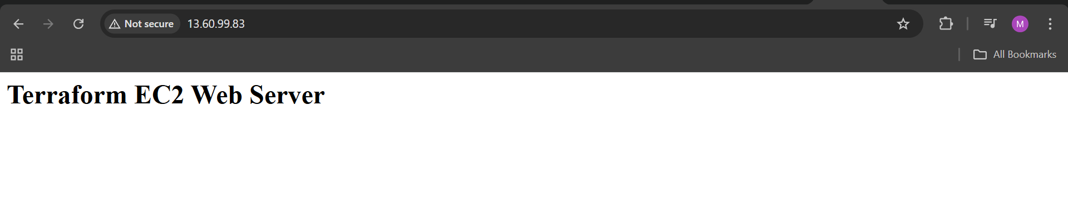

4. Set up S3 as backend for task 3.

- Login to AWS Console
- Go to S3 → Buckets
- Confirm the bucket is created:
- mujahed-terraform-backend-2026
- Verify the bucket region is:
- Europe (Stockholm) eu-north-1
- This bucket will be used to store Terraform remote state

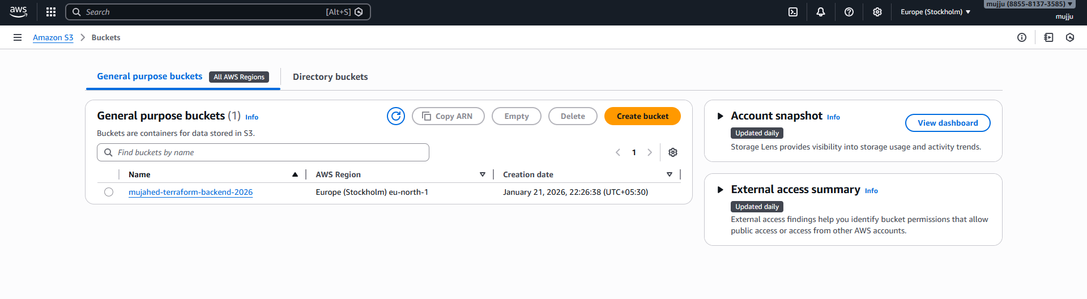
- Open main.tf in VS Code.
- Scroll to the bottom and add backend block:
- terraform {
- backend "s3" {
- bucket = "mujahed-terraform-backend-2026"
- key = "task3/ec2-httpd/terraform.tfstate"
- region = "eu-north-1"
- }
- }
- Save the file.
- This ensures Terraform state is stored remotely in S3.

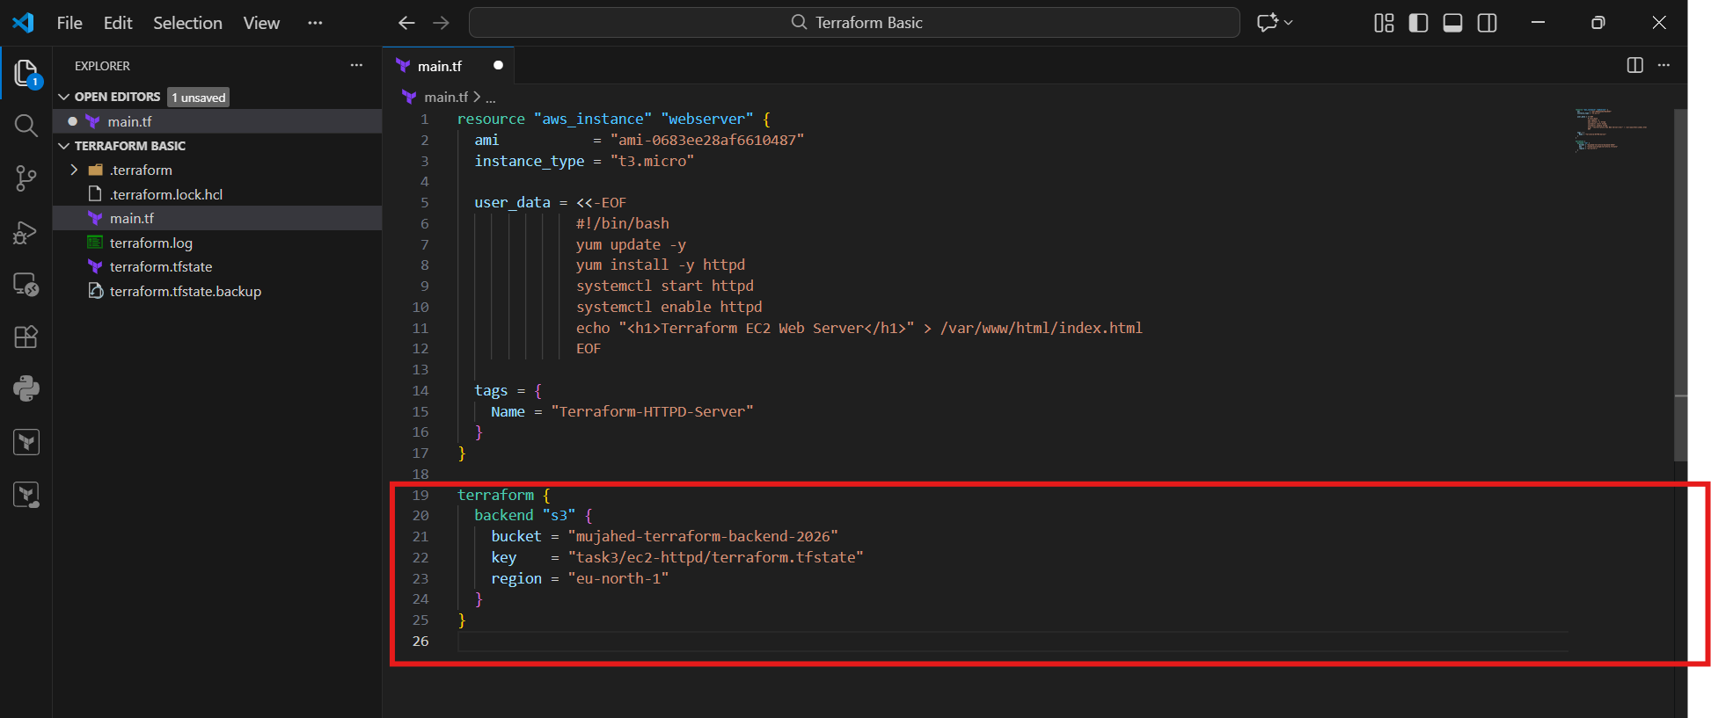
- Open VS Code Terminal.
- Run:
- terraform init
- Terraform asks:
Do you want to copy existing state to the new backend?
- Type:
- yes
- Confirm message appears:
- Successfully configured the backend "s3"
- Terraform has been successfully initialized

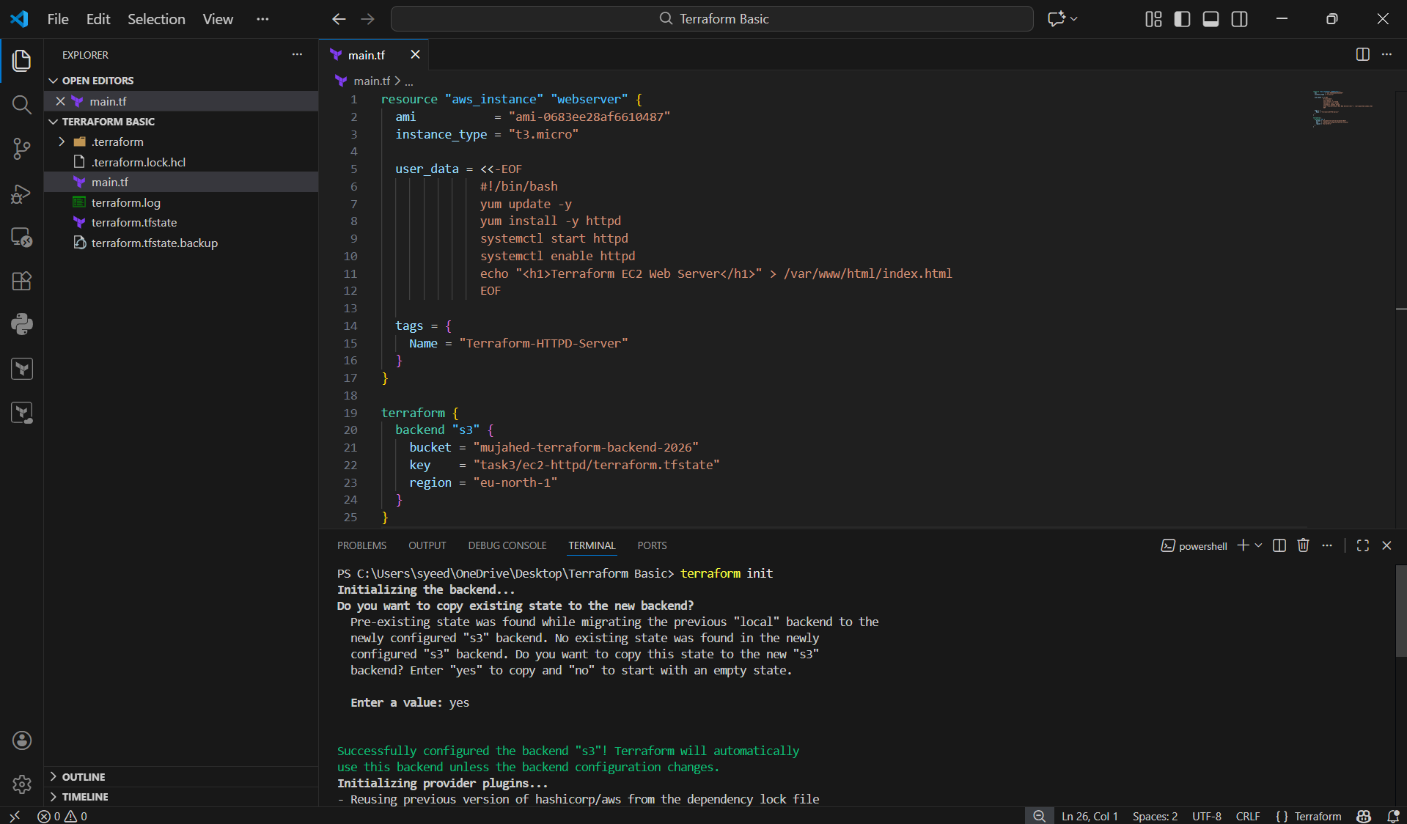
- In terminal, run:
- terraform apply
- Terraform checks AWS resources using remote state.
- You see output like:
No changes. Your infrastructure matches the configuration.
- This means everything is already created and matching.

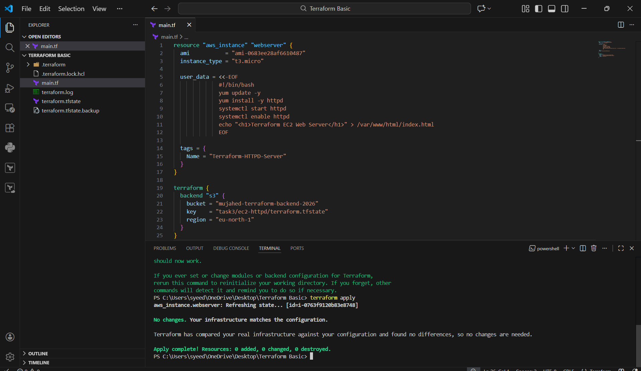
- Terraform completes the execution.
- Confirm final message:
- Apply complete! Resources: 0 added, 0 changed, 0 destroyed.
- This confirms:
- Backend is working properly
- Terraform state is stable in S3
- No updates required

